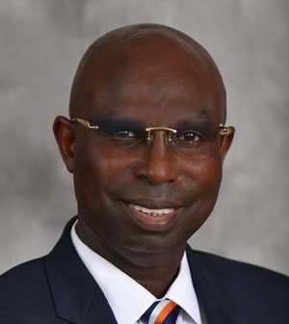

Dr. Etienne Musonera is a Professor of Marketing in the School of Business, Mercer University (Atlanta, Georgia). He has taught a variety of marketing and management courses including Marketing Strategies & Decision Making; Marketing Research; Consumer Behavior; Marketing Communication and Promotion; International Marketing and Management; Project Management, Business Research, Operations and Production Management. Dr. Musonera was a William Davidson Institute Faculty Affiliate at the University of Michigan and has taught Marketing in the Goldman & Sachs Women Entrepreneurship Program in Rwanda. He also taught Project Analysis and Design, Project Cycle, Evaluation and Audit in the Executive MBA program at the School of Finance and Banking (SFB) in Rwanda (under United Nations Development Program (UNDVP)).

He has designed and conducted short course training in Marketing Strategies, Project Management, and Quality Management. Dr. Musonera holds a unique Interdisciplinary Doctor of Philosophy (II PhD) in both: (I): International Marketing and (II): Industrial Engineering from Wayne State University. He has a Master of Science (MSIE) in Industrial & Manufacturing Engineering from Wayne State University, a Master of Science (MS) in Engineering Management from Western Michigan University.

Dr. Musonera is very active in consulting and offers a unique expertise in Marketing & Business Strategies, Foreign Direct Investment, Decision Risk Analysis, Lean Six Sigma, Business Process Management, Project Engineering Management, Quality Management, and World Class Manufacturing (WCM) Best Strategies and Practices, Supply Chain and Operations Management, Business and Marketing Plans. Dr. Musonera believes that improving conditions that are conducive to Foreign Direct Investment (FDI) will attract World Class Multinational Enterprises and would affect positively a country’s economic growth, learning and absorptive capacity building to survive in a global competitive environment. Dr. Musonera is included in Who’s Who in Finance and Business; Marquis Who’s Who in America, and He is a lifetime Honored Member of the Cambridge Who’s Who Registry of Executives and Professionals.

He is a Board Member and President of the Association of international Business Research and Practices (AIBRP). Dr. Musonera has an extensive experience in the manufacturing industry: He worked for General Motors Corporation (GM) and has held several positions such as Manufacturing Quality Systems Engineer (MQSE), Reliability Engineer (RE), and Quality Engineer (QE). He traveled to General Motors’ manufacturing plants across Canada, USA and Mexico overseeing Manufacturing Quality Systems and Project Engineering activities.

